**Opti 528 Project Update**

Alex Rodack, Justin Knight, and Phil Scott

Our project’s goal was to examine the effects on imaging of turbulence looking down at the earth through the atmosphere. For our first stage we decided the important topics would be to perform a first order analysis of what was needed for our system, to analyze the effects of placing a set turbulence layer different distances along the path, and to judge whether the AOAtmo class would be appropriate for our project. Our initial findings were presented in class and the power point has been made available. Since this, we have continued to work on the problems we encountered and have fixed mistakes and found new areas to explore.

Our first task was to look back at the first order analysis of our system and validate our results along with flushing out any important details we missed on our first pass. We’ll still be using a .5” x.5” CCD with 3µm square pixels. This means we have approximately an 18MP camera to perform our analysis. We’d still like to operate using the Johnson criteria for identifying objects which is about 7 pixels across the small dimension which would lead us to a magnification of .0005512 which means that at 10km we’d need a telescope focal length that is 5.512m long. This is a little long, but we don’t think it’s unreasonable once the path is folded a bit. Using the Rayleigh resolution criteria with 2 pixels across the airy disk, we found our diameter to be 56.04cm using the equation $D= \frac{.61λf}{(Pixel Size)}$. This yields an F/9.84 system which would be able to differentiate different letters in the absence of turbulence.

The next task we tackled was finding a reasonable wind speed model so that we could use the Hufnagel Valley Model to find our Cn2 values at various altitudes. This would make our r0 values much more believable since our first pass was simply guessing wind speeds. We also plan on breaking our total altitude up into finer steps so our Riemann sum of the Cn2 better approximates the integral needed for the calculation. We found a Gaussian fit[1] to approximate wind speed at heights above Tucson and plan on using this value in our further assessments.

Another imaging issue that we thought would help make our model more realistic is to analyze PSFs for different isoplanatic patches. This is something we are hoping to accomplish in time for our final presentation, but we haven’t yet made much headway into this area. We plan on calculating our patch sizes as well as our coherence times in the future.

The final detail we are hoping to include is getting our plate scales correct so we can see a realistic effect of turbulence on our images.

Performing these tasks/calculations will give us an idea of what we would need to accomplish hardware-wise to use adaptive optics should we find it necessary. This includes how fast we would need to run our servo, how many actuators we would need, and what layer of the turbulence between our camera and our target would provide the most effective result if it is corrected. Other issues that we are still in the process of thinking about are practical in nature, along the lines of what could we use as a guide star if we are looking down, and what the turbulence is that is caused by our aircraft flying our telescope.

Now that we have described what we have done since you last heard from us, we thought we could provide some further detail by discussing the changes made in our simulation code. As might be recalled, we had a severe focusing issue during our presentation. This was fixed by having the simulation turn off the turbulence, and iteratively add defocus to the system until a well-defined PSF was observed (both by eye and via the value of the highest pixel value). One could think of this as simply turning the focusing knob on the telescope until what is expected in the diffraction limited case is what is observed. This was mainly only an issue for the propagation method we were using however, because John’s code provides the geometry factor in AOAtmo, which was turned off to fix that particular method. Following the advice of John and the results we saw after some code debugging, we have decided to go forward with only the AOAtmo model. We do not see scintillation being something we need to account for, especially after the model that included its effects was shown to not degrade the final image quality by very much comparatively.

As mentioned above, we have also integrated in a more realistic model for the turbulence by using actual data for wind speeds above Tucson to estimate Cn2 values. We then integrate the Cn2 profile over our layer thickness to produce a more true to “real-world” r0. Because the Hufnagel Valley Model depends on the “A” coefficient, or value of Cn2 at ground level, we assumed a ground layer turbulence with r0 equal to 5cm, and then used our wind speed model with Hufnagel Valley to compute the r0 for the layer above that to our camera (1km to 10km altitude). This allows us to remove the A coefficient’s effect from the real data we have (this was found through experimenting with our model by changing A and seeing that the resulting r0 over the bounds of this layer was unaffected). A plot is shown below of the Cn2 profile our model creates in figure 1. We also changed the order of the layers as they are placed into our AOAtmo object in order to better reflect our downward looking scenario (the layers essentially go now from 10km to ground, instead of ground to 10km).

Finally, we sured up the simulation by changing the controllable parameters to match those of our refined first order analysis. This includes the new diameter of our primary mirror, and our plate scales most specifically. Shown below in figure 2 is the final result of our updated simulation. As can be easily seen, the quality of the image after the focusing knob adjustment is vastly improved. We also see the effect of changing the order of the layers because the smaller r0 layer is now closest to our object, meaning it is “stretched out” more over it, and has less of a damaging effect on our imaging quality. Although the quality looks fairly decent, if we zoom in on the image to look for our target license plates, we see that all that information is destroyed by the turbulence (See figure 3). This, from a somewhat quantitative, but mostly qualitative standpoint, tells us to accomplish our system task of resolving license plate letters, we will likely need AO should it be possible to achieve. Again, as mentioned above, this particular model does not include any information about isoplanatic patches. It assumes the same PSF is valid across the entire scene. It in this case also does not include a layer of turbulence associated with what is caused by the aircraft our telescope is mounted to, which would likely blur us out somewhat more than is seen here. These two things, along with determining if performing AO is even possible, is what we hope to have to present to you next week.

________________________

<https://www.opticsinfobase.org/oe/fulltext.cfm?uri=oe-19-2-820&id=209334>

Figures:

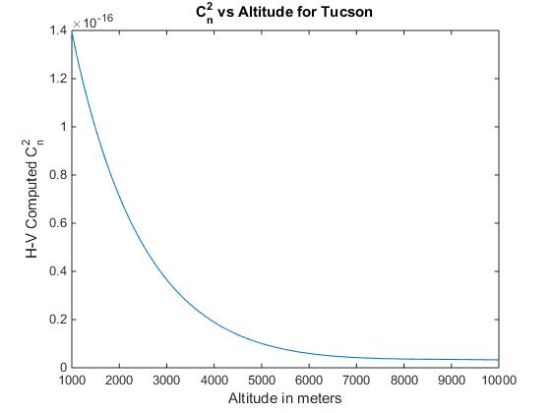

Figure : Cn2 Profile for Tucson

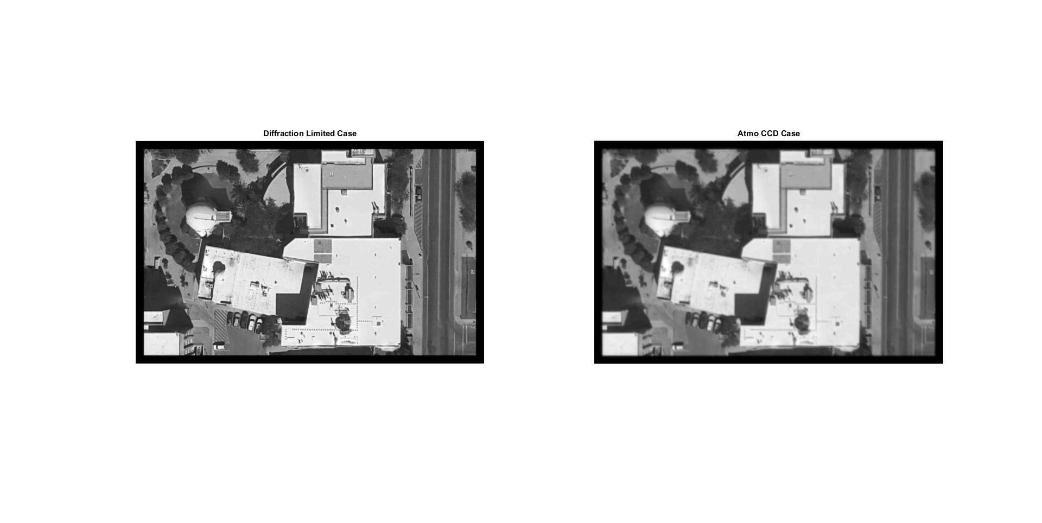

Figure : Diffraction Limited vs. Turbulence Result

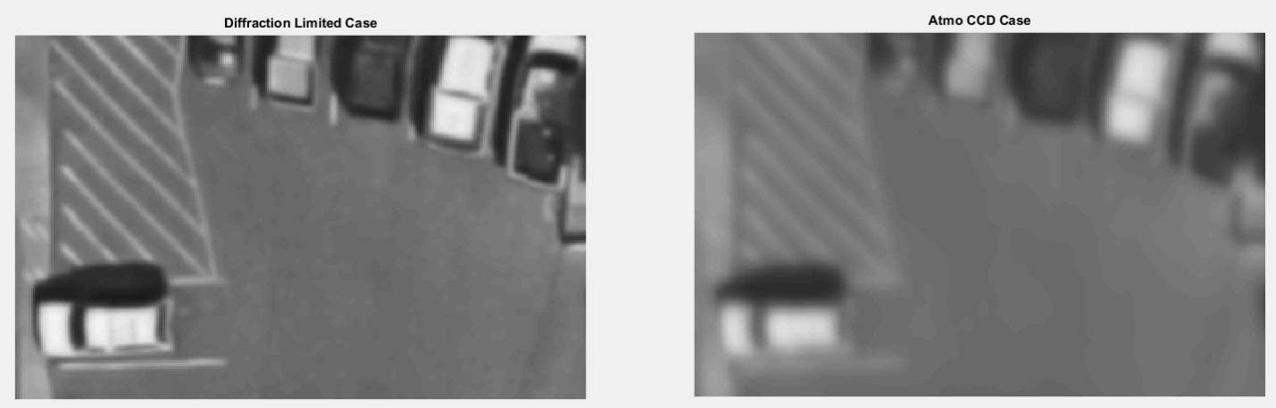

Figure : Looking at the Cars in the Parking Lot

1.